Quick guide for Approvers (Connect Marketing)

Click on the links below to jump to each section:
- How to access orders for approval
- How to approve orders
  - Top tips for approving template items
- Frequently Asked Questions

How to access orders for approval
As an Approver, there are two ways to access any orders that require approval:
- You will receive an email notification whenever an order requires approval. Simply click on the link in the email, which will take you to order approvals.
- Or you can log-in directly to Connect Marketing, then navigate to Approvals via the account dropdown menu.
Note: Approver username = your email address in lowercase. (There is an option to reset your password at the log-in screen if you’ve forgotten this).

How to approve orders

STEP 1:
Go to the account dropdown menu and click on Approvals.

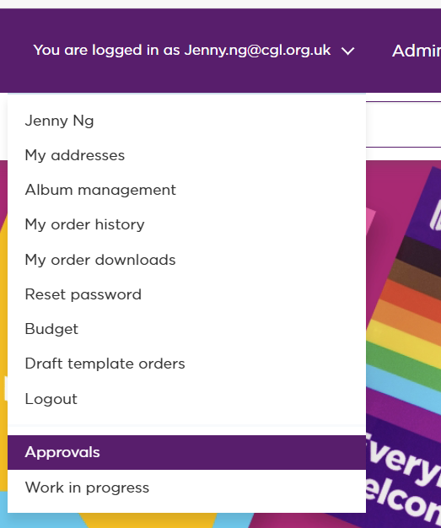

STEP 2:
Click within a specific order which will expand the view to show more order details, where you can then click to ‘Approve’ or ‘Cancel’ the order.
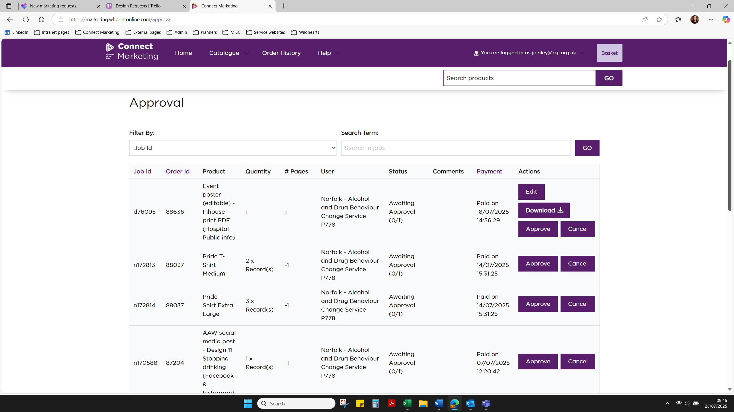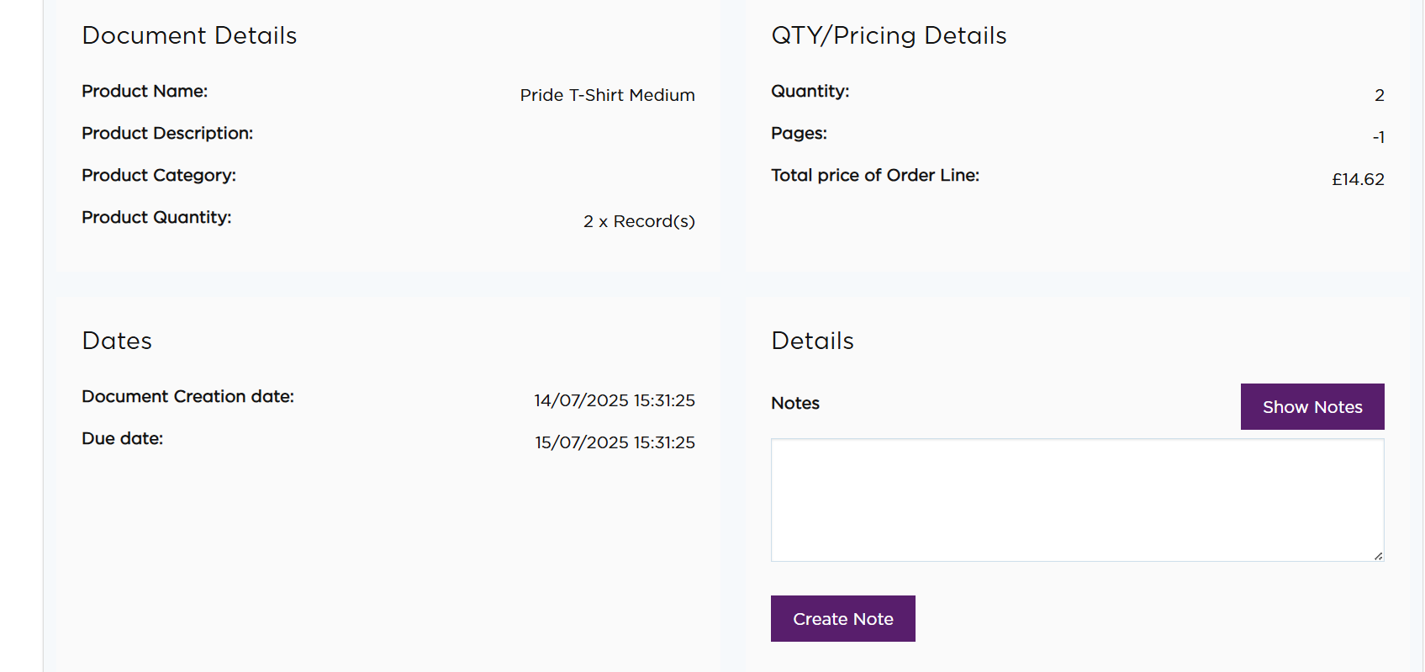
Expanded view of specific order details

TOP TIPS FOR APPROVING TEMPLATE ITEMS
If an order has an ‘Edit’ button under Actions, this means it is an editable template item that has been customised, so you should double check the content is correct.
It is crucial that you double check any edited items are correct, as once approved, the item cannot be refunded if an error is found later on. For example, check:
  - Default example text: most templates will have ‘XXXX’ or other default placeholder text for any editable fields (see below example). Check that these have been updated or removed.
  - Service-specific details (eg contact info): have these been added in and are they accurate?
  - Text sections: check for any typos and that all text is present, and not cut off the page (see example of cut-off bullet text below)
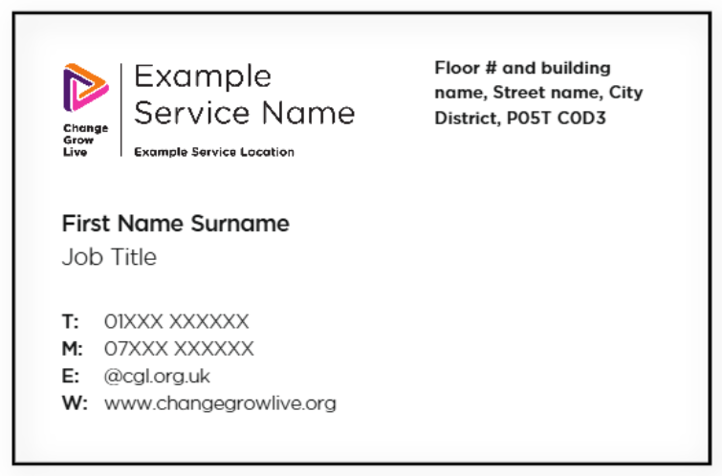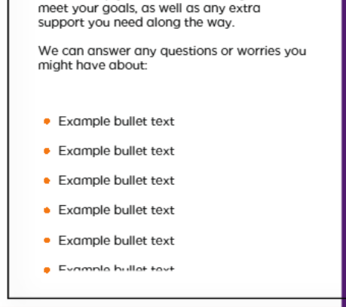
- You will have the option to ‘Download’ the item to check it in detail. You can then ‘Edit’ the item if needed, before approving it.

Get in touch if you need further support
If you have any further questions or need any updates to your access, fill in our Request Form and someone from the team will be happy to help you.
You can also take a look at our Frequently Asked Questions on the next page.

Frequently Asked Questions

What’s the difference between an Approver and a Primary User?

 | Approver | Primary User
Account type | Set up with an individual account | Set up on a shared service account.
Username | Email address in lowercase | Starts with the P (or H) code, followed by location and service in all capitals (eg P1316 BROMLEY ADULT)
Access type | To review and approve/cancel any orders placed on the service account(s) they are allocated to | To place orders
Useful info | Can be allocated as approver to multiple cost codes as needed | Log-in details can be shared with other team members who may need to place orders

Can Approvers view the resources available?
Yes, you can view the resources available. However, as the main role of an Approver is to review and approve orders, there is no budget allocated for you to place orders yourself.

Am I able to order resources as well as approve orders?
The recommendation is to have separate people as an Approver and User. This is to avoid the risk of any errors being missed, as the Approver can act as a second pair of eyes to check over orders. As most items are print-on-demand, the supplier can't refund orders if there is a mistake made by the person who placed the order.
However, if there is a specific reason why you need to have access to place orders as well, please get in touch via the Request Form and we can discuss this with you.

I am trying to order an editable item, but it shows an ‘Example service logo’. Why is this?
As an Approver, your access is for viewing items only, not to order them as well. If an order needs to be placed, please ask the Primary User to place the order via the shared service account.
You can make any corrections needed to the item when it comes through to you for approval.

Why does my budget show a zero balance?
As an Approver, your access is for viewing items only, so your account does not have an allocated budget.
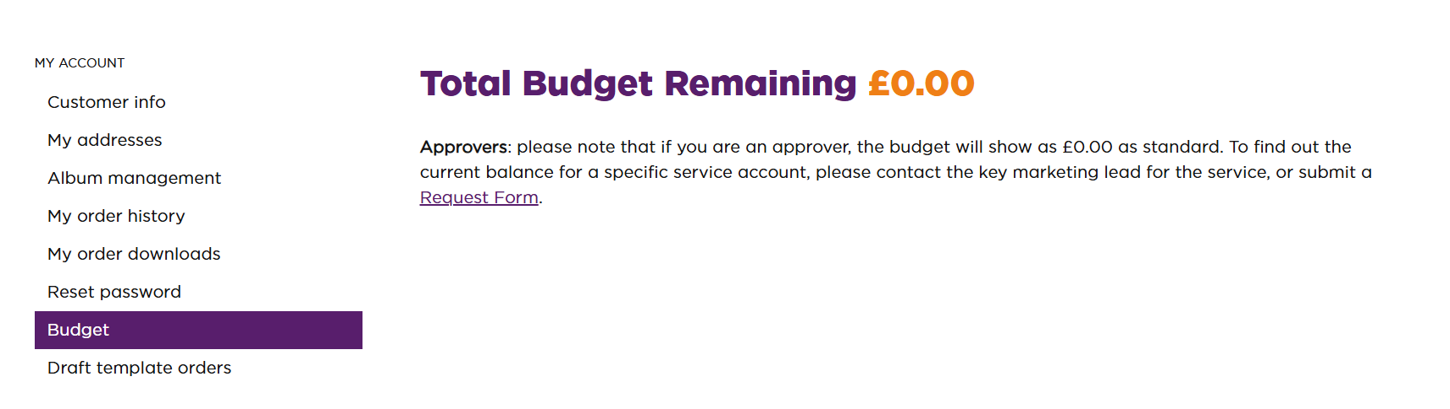

How do I view my service’s current budget balance?
There are two ways:
- Ask the Primary User, who can log into the shared service account to view this.
- Or you can get in touch via the Request Form and we can look this up for you.

Who is the Primary User for my service?
This will generally be the Marketing Champion/local Comms Lead for your service. If you are not sure who this is, please get in touch via the Request Form and we can look up who is allocated as the Primary User on the system.

Can another Approver be added to a service account?
Yes! It is helpful to have at least one additional Approver, as this avoids delays with orders being approved (e.g. if the main approver is away). There can be up to three Approvers on each service account.
Simply complete a Request Form with the details of who needs to be added (or changed) and to which service/cost code, and we can get this set up.

If there is more than one Approver, do they ALL have to confirm approval?
No. The approvals email notification will go to all Approvers on the account, but only one needs to review and confirm approval.

I am an Approver, what do I need to check exactly?
Check the item details and quantity are what you’d expect.
For any editable items, it is crucial to double check the contents are correct as, once approved, the item cannot be refunded if an error is found later on. (See ‘Top tips for template items’)

I no longer need to be the Approver for a service. How do I update this?
Simply complete a Request Form with the details of who should replace you as the approver, as well as reconfirming the service/cost code, and we can update this.

I can’t find the answer I’m looking for. Can you help?
Of course! Please complete a Request Form and we’ll get in touch to see how we can help.

